**Use Case Diagram for Utility Store**

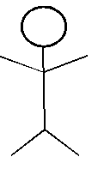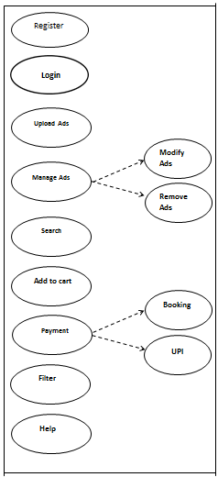 Utility Store



Admin

Seller

Buyer